**Отчет по лабораторной работе №7**

**Савинов Егор ИУ7-74Б**

**Задача 1**

|  |  |  |  |
| --- | --- | --- | --- |
| № | Binary CIDR | IPv4 | Mask |
| 1 | 11000000.10101000.00000110.00000000/27 | 192.168.19.0 | 255.255.255.224 |
| 2 | 11000000.10101000.00000110.00100000/27 | 192.168.19.64 | 255.255.255.224 |
| 3 | 11000000.10101000.00000110.01000000/27 | 192.168.19.128 | 255.255.255.224 |
| 4 | 11000000.10101000.00000110.01100000/30 | 192.168.19.160 | 255.255.255.252 |
| 5 | 11000000.10101000.00000110.01100100/30 | 192.168.19.164 | 255.255.255.252 |
| 6 | 11000000.10101000.00000110.01101000/30 | 192.168.19.168 | 255.255.255.252 |

**Задача 2,3,5**

На примере Router1

Router>en

Router#conf t

Router(config)#interface GigabitEthernet0/0/0

Router(config-if)#ip address 192.168.19.62 255.255.255.224

Router(config-if)#ipv6 enable

Router(config-if)#ipv6 address 2001:7::1/64

Router(config-if)#no sh

Router(config-if)#ex

Router(config)#interface GigabitEthernet0/0/1

Router(config-if)#ip address 192.168.19.126 255.255.255.224

Router(config-if)#ipv6 enable

Router(config-if)#ipv6 address 2001:8::1/64

Router(config-if)#no sh

Router(config-if)#ex

Router(config)#interface vlan 1

Router(config-if)#ip address 192.168.6.161 255.255.255.252

Router(config-if)#ipv6 enable

Router(config-if)#ipv6 address 2001:10::1/64

Router(config-if)#no sh

Router(config-if)#ex

Router(config)#ip dhcp pool pool1

Router(dhcp-config)#network 192.168.19.0 255.255.255.224

Router(dhcp-config)#default-router 192.168.19.62

Router(dhcp-config)#ex

Router(config)#ip dhcp pool pool2

Router(dhcp-config)#network 192.168.19.64 255.255.255.224

Router(dhcp-config)#default-router 192.168.19.126

Router(dhcp-config)#ex

Router(config)#ip route 192.168.19.128 255.255.255.224 192.168.19.162

Router(config)#ip route 192.168.6.164 255.255.255.252 192.168.6.162

Router(config)#ip route 192.168.6.168 255.255.255.252 192.168.6.162

Router(config)#ipv6 route 2001:9::/64 2001:10::2

Router(config)#ipv6 route 2001:11::/64 2001:10::2

Router(config)#ipv6 route 2001:12::/64 2001:10::2

Router(config)#ipv6 unicast-routing

Router(config)#ex

Router#ex

**Задача 4**

На примере PC1.1

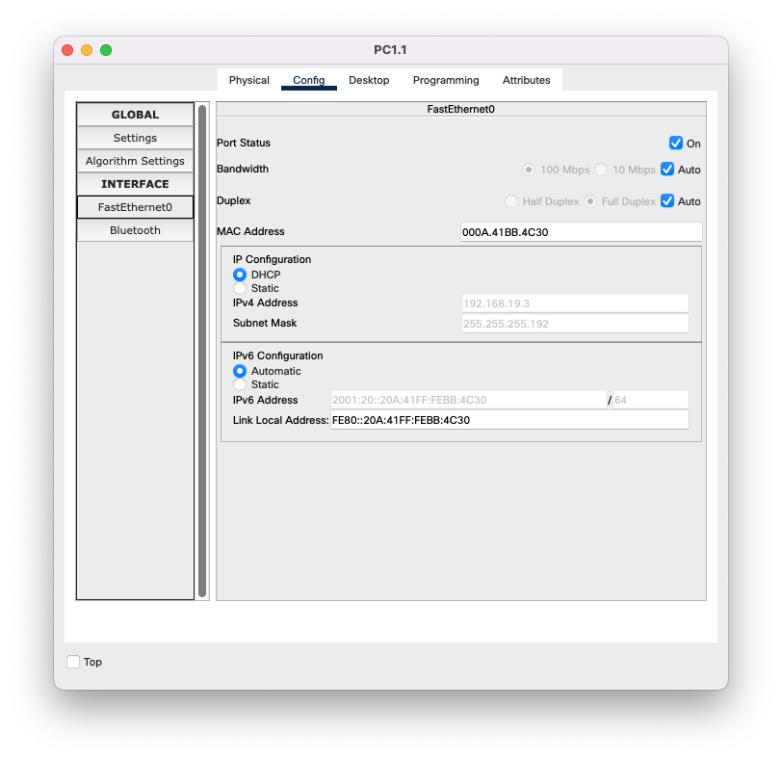

Подключение службы DHCPv6

